

Database Systems

Assignment 2

**Total Marks: 100**

**Due Date: 22 November 2024**

**Related topics: DDL, Basic DML**

**Instructions:**

1. Assignment must be submitted on portal in one word document
2. Late submission will cause you to lose 10% per day. After three days of deadline no submissions will be entertained.
3. Refrain from copying other student’s assignments. You will be awarded with zero marks in that case.

**Q1. Implement the given schema using DDL commands in SQL. Choose the appropriate action (restrict, cascade, set NULL, set default) for each referential integrity constraint, both for the deletion of a referenced tuple and for the update of a primary key attribute value in a referenced tuple. Give screen shots for all the commands with the SQL success message that the command has been executed successfully.** **(35 Marks = 7 tables X 5 marks each )**

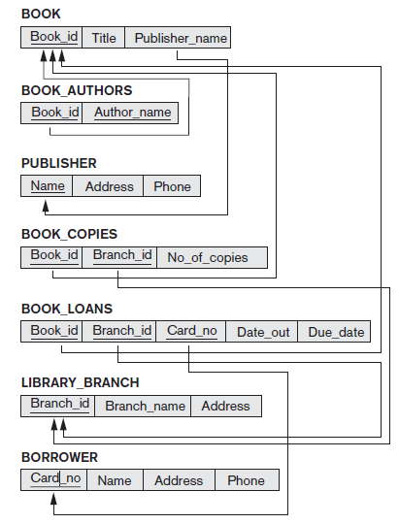

**Q2. Insert meaningful data in the specified tables (5 rows per table). While inserting this data if any problem occurs. Please state it with proper error message. Then also describe how you solved it to enter all the data.**

**Give screen shots for all the commands with the SQL success message that the command has been executed successfully. (15 Marks)**

**Q3. Execute the following queries on database that you created and give the screenshots of query and the result. (50 Marks = 5 Marks x 10 queries)**

***Note: Use JOIN keyword wherever applicable. Do not Use cross product or Multi Table Select. It will not earn you any marks in that particular query.***

1. Name all the borrowers who have a phone number and live in ‘Lahore’ (Note: Address field has data in which Lahore is somewhere in the string. Example ’24 A Khayaban-e-Jinnah Lahore, Pakistan’)
2. Show names of all the book which have less than 10 copies in any branch.
3. Show branch names with the book names they have along with the number of copies.
4. Show borrower names who have borrowed some book named as ‘The Kite Runner’.
5. Show borrower names who have borrowed some books from a library branch which is located in ‘Karachi’. (Note: Address field has data in which Lahore is somewhere in the string. Example ’24 A Khayaban-e-Jinnah Lahore, Pakistan’).
6. Show book names along with their author names for those books which are published by ‘Rehman Publishers’.
7. Show all publisher names who do not have a phone number but they have published a book named ‘Alchemist’.
8. For each book that is loaned out from the ‘Iqbal Town branch’ and whose Due_date is today, retrieve the book title, the borrower’s name, and the borrower’s address (Use Date Function)
9. Show all the book names which are loaned out and due date is in September.
10. Show branch names from which a book has been loaned out by a borrower named ‘Ali Ahsan Khan’.

================================ GOOD LUCK ================================